History of Document
Version | Date | Additions/Modifications | Prepared/Revised by
00 | 26-Nov-24 | Draft Version | Sutono Wu

Table of Contents
1. History of Document 1
2. Table of Contents 2
3. Stakeholders Involved 2
4. Risk Analysis 3
4.1 Data 3
4.2 System 4
4.3 Secure SDLC 4
5. Overview 5
6. Functional Design 6
6.1 Design Details 6
6.2 Access Method or Path 6
6.3 System Design User Interface 6
6.3.1 Selection Screen 6
6.3.2 Output Screen 6
7. Technical Design 8
7.1 Design Details 8
7.2 Input Parameters 8
7.3 Process 9
7.4 Output Parameter 17
8. Authorization Control 18
8.1 Security Requirements 18
9. Appendix 19
9.1 Version 1.0 Deployment 19
9.1.1 Document Approval 19
9.1.2 Pre-Deployment Checklist 19
9.1.3 Post-Deployment Checklist 19

Stakeholders Involved
The following people are stakeholders involved in the requirement-gathering process and have confirmed the content of this document.
 | Name |  | Organization/Title
Meliana |  | PTSN / BPO
Stephen Yong |  | PTSN / Key User
Venny |  | PTSN / Key User
Sutono |  | PTSN / Internal Consultant

Risk Analysis

Data
Object |  | Remark

System
 | System |  | Remark
ODOO |  | N/A
MIDDLEWARE |  | N/A
CORAMES |  | N/A
NUSAMES |  | N/A

Secure SDLC
 | Phases | Remark
Planning & Security Requirement |  | N/A
Secure Design & Prototyping |  | N/A
Secure Development |  | N/A
Security & Vulnerability Testing |  | N/A
Secure Deployment |  | N/A
Maintenance & Monitoring |  | N/A

Overview
Since the implementation of module PM, user when processing transfer equipment (or asset that linked to equipment) system will check if there’s any related maintenance plan that is still active and will delete the plan as the equipment is transferred to other plant.

But there’s issue when there is multiple equipment is being transferred and multiple maintenance plan that needs to be recreated in order for the order to be generated, hence there’s the request to mass create the maintenance plan.

Functional Design

Design Details
Standard SAP allows users to create maintenance plans individually using transaction code IP01. To streamline the process of creating multiple maintenance plans, particularly for large-scale equipment transfers, this enhancement enables mass creation and automatic scheduling of maintenance plans.

Access Method or Path
Execution:
Custom Transaction Code : ZPM_UPLD_MAINTPLAN – Maintenance Plan Upload
Menu Path : ________
Standard Transaction Code : ________
Other : ________

System Design User Interface

Selection Screen
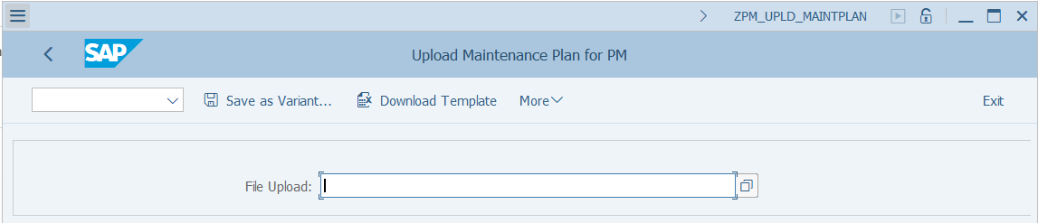
Input parameters
Field Description | Type (text or numeric) | Mandatory | Field Type
File Upload | FILE PATH | Mandatory | Single File

Output Screen
Sequence | Field Description
 | Short Text (10 Chars) | Medium Text (20 Chars) | Long Text (40 Chars)
1 | Desc | Description | Description
2 | Maint Stra | Maintenance Strategy | Maintenance Strategy
3 | Eq No | Equipment Number | Equipment Number
4 | Func Loc | Functional Location | Functional Location
5 | S.F.Late | Shift Factor Late | Shift Factor Late Completion
6 | S.F.Early | Shift Factor Early | Shift Factor Early Completion
7 | Tolerance+ | Tolerance (+) | Tolerance (+)
8 | Tolerance- | Tolerance (-) | Tolerance (-)
9 | Cycle Mod | Cycle Mod Factor | Cycle Modifier Factor
10 | Call Hz | Call Horizon | Call Horizon
11 | Call HzDay | Call Horizon (Days) | Call Horizon (Days)
12 | Calc Type | Calculation Type | Calculation Type
13 | Auth Grp | Authorization Group | Authorization Group
14 | Maint Cat | Maint Plan Category | Maintenance Plan Category
15 | Sched | Scheduling Period | Scheduling Period
16 | Unit | Unit | Unit in scheduling interval
17 | Start Cycl | Start of cycle | Start of cycle
18 | Sort field | Sort field | Sort field
19 | Item Text | Maint Item Text | Maint Item Text
20 | Equipment | Equipment | Equipment
21 | Creat Ind | Creation Indicator | Creation Indicator
22 | Task Type | Task List Type | Task List Type
23 | Task Group | Task List Group | Task List Group
24 | GrpCounter | Group Counter | Group Counter
25 | Plan Grp | Planner Group | Planner Group
26 | W.Center | Work Center | Work Center
27 | Maint Plan | Maintenance Plant | Maintenance Plant
28 | Plan Plant | Planning Plant | Planning Plant
29 | Order Type | Order Type | Order Type
30 | Act Type | Activity Type | Maintenance Activity Type
31 | Maint Cat | Maintenance Category | Maintenance Category
32 | Maint Cyc | Maintenance Cycle | Maintenance Cycle
33 | Unit | Unit | Unit
34 | Cycle Text | Cycle Text | Cycle Text
35 | Mea Point | Measuring Point | Measuring Point
36 | Message | Message | Message
37 | Msg Text | Message Text | Message Text

Technical Design

Design Details
Create custom upload program for user to upload file using excel file (.xlsx) to massive create maintenance plan using BAPI.
Process Area | Industry Print Reference | Process Flow | Activity Description
PM | PM-110 | Maintain Maintenance Plan | Maintenance Plan

System should provide excel template for user to download before submit their data.

Input Parameters
Field Description | Type (text or numeric) | Field Type | Show in Template
Creation Indicator | CHAR (1) | Mandatory
Created On | DATS (10) | Mandatory
Created By | CHAR (12) | Mandatory
Description | CHAR (40) | Mandatory | X
Maintenance Strategy | CHAR (6) | Optional | X
Equipment Number | CHAR (18) | Conditional Mandatory | X
Functional Location | CHAR (40) | Conditional Mandatory | X
Shift Factor Late Completion | NUMC (3) | Optional | X
Shift Factor Early Completion | NUMC (3) | Optional | X
Tolerance (+) | NUMC (3) | Optional | X
Tolerance (-) | NUMC (3) | Optional | X
Cycle Modifier Factor | DEC (4) | Mandatory
Call Horizon | NUMC (3) | Conditional Mandatory | X
Call Horizon (Days) | NUM (3) | Conditional Mandatory | X
Calculation Type | CHAR (3) | Mandatory | X
Authorization Group | CHAR (4) | Mandatory | X
Maintenance Plan Category | CHAR (2) | Mandatory | X
Scheduling Period | NUMC (3) | Mandatory | X
Unit in scheduling interval | UNIT (3) | Mandatory | X
Start of cycle | DATS (10) | Mandatory | X
Sort field | CHAR (40) | Mandatory | X
Maint Item Text | CHAR (40) | Mandatory
Equipment | CHAR (18) | Conditional Mandatory
Creation Indicator | CHAR (1) | Mandatory
Task List Type | CHAR (1) | Mandatory | X
Task List Group | CHAR (8) | Mandatory | X
Group Counter | CHAR (2) | Mandatory | X
Planner Group | CHAR (3) | Mandatory | X
Object Type | CHAR (2) | Mandatory
Work Center | CHAR (8) | Mandatory | X
Maintenance Plant | CHAR (4) | Mandatory | X
Planning Plant | CHAR (4) | Mandatory | X
Order Type | CHAR (4) | Mandatory | X
Maintenance Activity Type | CHAR (3) | Mandatory | X
Maintenance Category | CHAR (2) | Mandatory | X
Maintenance Cycle | FLTP (22) | Mandatory | X
Unit | UNIT (3) | Mandatory | X
Cycle Text | CHAR (30) | Mandatory | X
Measuring Point | CHAR (12) | Conditional Mandatory | X

Process
System will process data based on input from user by running BAPI = MPLAN_CREATE and followed with BAPI_TRANSACTION_COMMIT, with additional default value to be maintained. Below is screenshot on how to populate the data:

Header:
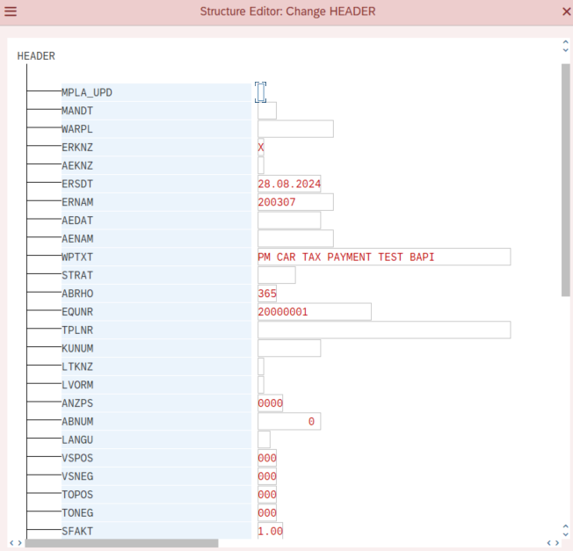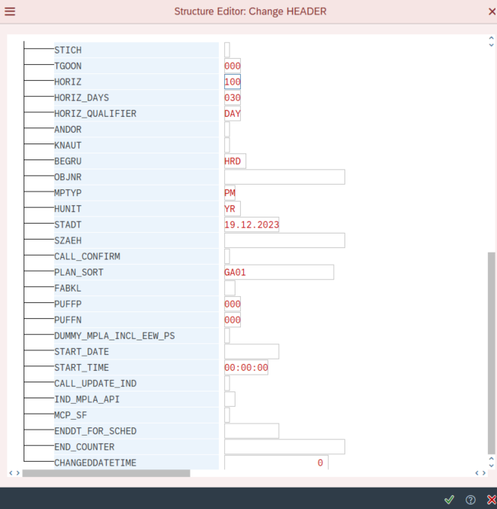
Item:
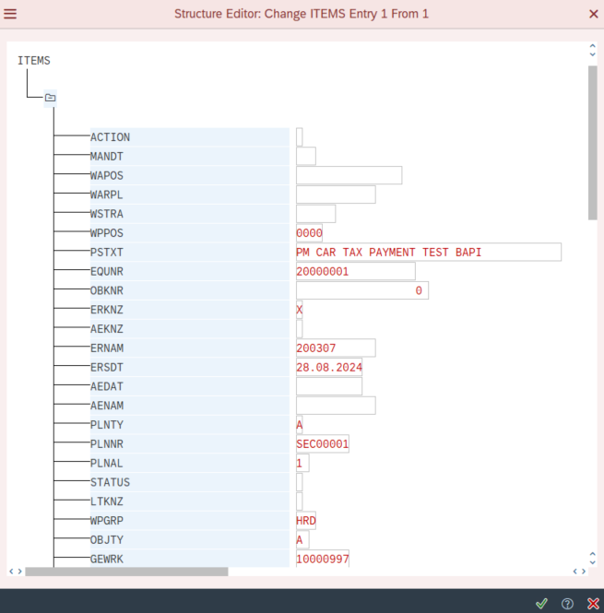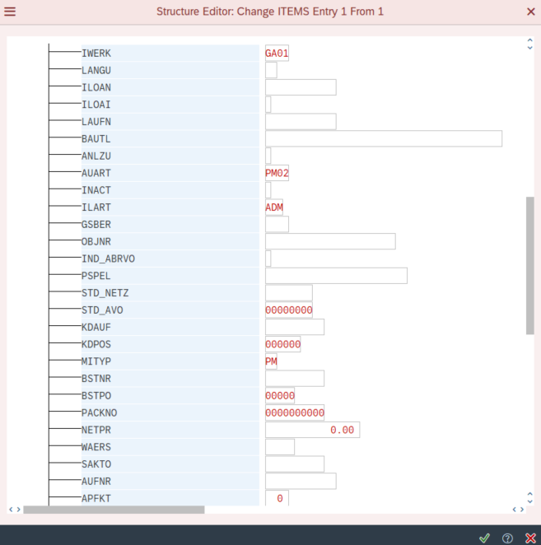

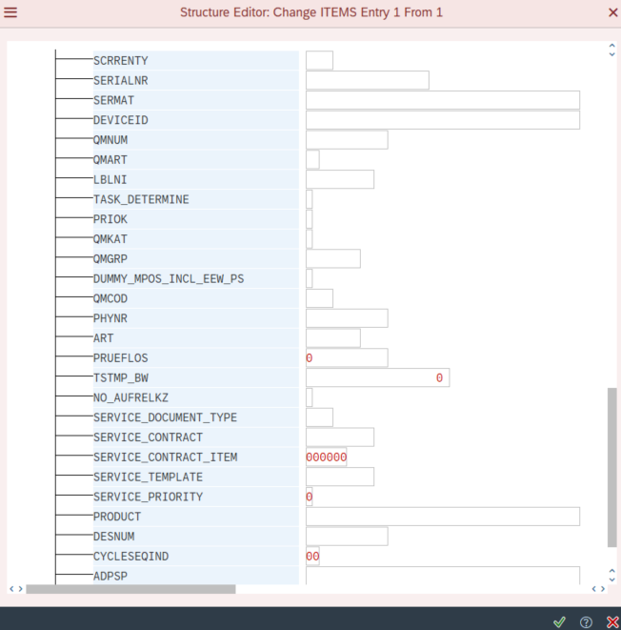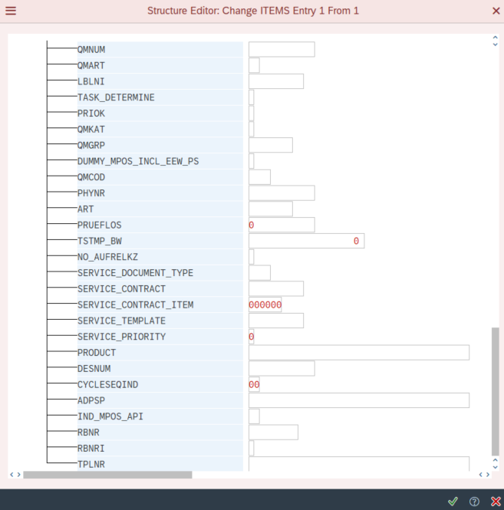

Cycle:
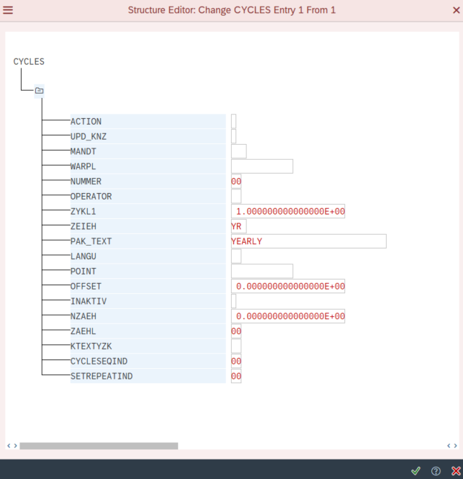

Field Description | Default | Type (text or numeric) | Field Type | Technical Field
Creation Indicator | X | CHAR (1) | Mandatory | ERKNZ
Created On | Default to current system date | DATS (10) | Mandatory | ERSDT
Created By | Default to current system date | CHAR (12) | Mandatory | ERNAM
Description |  | CHAR (40) | Mandatory | WPTXT
Maintenance Strategy |  | CHAR (6) | Optional | STRAT
Equipment Number |  | CHAR (18) | Conditional Mandatory | EQUNR
Functional Location |  | CHAR (40) | Conditional Mandatory | TPLNR
Shift Factor Late Completion |  | NUMC (3) | Optional | VSPOS
Shift Factor Early Completion |  | NUMC (3) | Optional | VSNEG
Tolerance (+) |  | NUMC (3) | Optional | TOPOS
Tolerance (-) |  | NUMC (3) | Optional | TONEG
Cycle Modifier Factor | Default to 1 | DEC (4) | Mandatory | SFAKT
Scheduling indicator | Default to 3 | CHAR (1) | Conditional Mandatory | STICH
Call Horizon |  | NUMC (3) | Mandatory | HORIZ
Call Horizon (Days) |  | NUM (3) | Conditional Mandatory | HORIZ_DAYS
Calculation Type |  | CHAR (3) | Mandatory | HORIZ_QUALIFIER
Authorization Group |  | CHAR (4) | Mandatory | BEGRU
Maintenance Plan Category |  | CHAR (2) | Mandatory | MPTYP
Scheduling Period |  | NUMC (3) | Mandatory | ABRHO
Unit in scheduling interval |  | UNIT (3) | Mandatory | HUNIT
Start of cycle |  | DATS (10) | Mandatory | STADT
Sort field |  | CHAR (40) | Mandatory | PLAN_SORT
Maint Item Text | Fill in with Maintenance Plan Description | CHAR (40) | Mandatory | PSTXT
Equipment | Fill in with equipment number | CHAR (18) | Conditional Mandatory | EQUNR
Creation Indicator | Default to X | CHAR (1) | Mandatory | ERKNZ
Task List Type |  | CHAR (1) | Mandatory | PLNTY
Task List Group |  | CHAR (8) | Mandatory | PLNNR
Group Counter |  | CHAR (2) | Mandatory | PLNAL
Planner Group |  | CHAR (3) | Mandatory | WPGRP
Object Type | Default to A | CHAR (2) | Mandatory | OBJTY
Work Center |  | CHAR (8) | Mandatory | GEWRK
Maintenance Plant |  | CHAR (4) | Mandatory | WERGW
Planning Plant |  | CHAR (4) | Mandatory | IWERK
Order Type |  | CHAR (4) | Mandatory | AUART
Maintenance Activity Type |  | CHAR (3) | Mandatory | ILART
Maintenance Category |  | CHAR (2) | Mandatory | MITYP
Maintenance Cycle |  | FLTP (22) | Conditional Mandatory | ZYKL1
Unit |  | UNIT (3) | Conditional Mandatory | ZEIEH
Cycle Text |  | CHAR (30) | Conditional Mandatory | PAK_TEXT
Measuring Point |  | CHAR (12) | Conditional Mandatory | POINT

Prior running BAPI, kindly find (populate) and validate data below:
- Set mandatory for above field that is set as mandatory and char count (except not show in template field as it will be maintained default by system).
Set conditional mandatory for field:
Field Description | Type (text or numeric) | Field Type | Remarks
Equipment Number | CHAR (18) | Conditional Mandatory | Validate if field not filled and functional location (TPLNR) is blank
Functional Location | CHAR (40) | Conditional Mandatory | Validate if field not filled and equipment (EQUNR) is blank
Scheduling indicator | CHAR (1) | Conditional Mandatory | Only to be fill in if STRAT has prefix “PB”
Call Horizon (Days) | NUM (3) | Conditional Mandatory | Validate if field not filled and when HORIZ_QUALIFIER = DAY
Measuring Point | CHAR (12) | Conditional Mandatory | Validate if field not filled and when Maintenance Strategy (STRAT) is filled and when STRAT has prefix “PB” only and entered measuring point should aligned with equipment (check via IMPTT where IMPTT.MPOBJ = prefix IE0000EQUNR)
Maintenance Cycle | FLTP (22) | Conditional Mandatory | Validate only if field Maintenance Strategy (STRAT) is not filled
Unit | UNIT (3) | Conditional Mandatory | Validate only if field Maintenance Strategy (STRAT) is not filled
Cycle Text | CHAR (30) | Conditional Mandatory | Validate only if field Maintenance Strategy (STRAT) is not filled
- Populate work center (GEWRK) by finding combination Work Center & Maintenance Plant (WERGW) in CRHD where CRHD.ARBPL = Work Center maintained & CRHD.WERKS = Maintenance Plant maintained, get CRHD.OBJID and populate as GEWRK.
- Validate field if filled differently:
Field Description | Type (text or numeric) | Field Type | Remarks
Maintenance Strategy | CHAR (6) | Optional | Entered Strategy should be found in T351.STRAT
Equipment Number | CHAR (18) | Conditional Mandatory | Entered Equipment should be found in EQUI.EQUNR
Functional Location | CHAR (40) | Conditional Mandatory | Entered Func Loc should be found in IFLOT.TPLNR
Calculation Type | CHAR (3) | Mandatory | Value entered should be either % or DAY
Authorization Group | CHAR (4) | Mandatory | Entered Authorization Group should be found in T370B.BEGRU
Maintenance Plan Category | CHAR (2) | Mandatory | Value entered should be PM or CL
Unit in scheduling interval | UNIT (3) | Mandatory | Value entered should be DAY, MON or YR
Start of cycle | DATS (10) | Mandatory | Format should be DD.MM.YYYY
Sort field | CHAR (40) | Mandatory | Entered Sort Field should be found in T399G.PLAN_SORT
Task List Type | CHAR (1) | Mandatory | Combination of Task List Type, Task List Group and Group Counter should be found in PLKO based on PLNTY, PLNNR and PLNAL where PLKO.WERKS = entered Maintenance Plant
Task List Group | CHAR (8) | Mandatory | Combination of Task List Type, Task List Group and Group Counter should be found in PLKO based on PLNTY, PLNNR and PLNAL where PLKO.WERKS = entered Maintenance Plant
Group Counter | CHAR (2) | Mandatory | Combination of Task List Type, Task List Group and Group Counter should be found in PLKO based on PLNTY, PLNNR and PLNAL where PLKO.WERKS = entered Maintenance Plant
Planner Group | CHAR (3) | Mandatory | Entered Planner Group  should be found in T024I.INGRP
Work Center | CHAR (8) | Mandatory | Combination Work Center & Maintenance Plant should be found in CRHD where ARBID & WERKS = Work Center & WERKS
Maintenance Plant | CHAR (4) | Mandatory | Combination Work Center & Maintenance Plant should be found in CRHD where ARBID & WERKS = Work Center & WERKS
Planning Plant | CHAR (4) | Mandatory | Entered planning plant should be found in T001W.WERKS
Order Type | CHAR (4) | Mandatory | If Maintenance Plan (MPTYP) = PM, then value should be “PM02”, if MPTYP = CL, then value should be “PM05”
Maintenance Activity Type | CHAR (3) | Mandatory | Check combination Order Type & Maintenance Activity Type should be found where T350I.AUART & T350I.ILART = entered Order Type and Maintenance Activity Type
Maintenance Category | CHAR (2) | Mandatory | Should be the same with Maintenance Plan Category (MPTYP)
Unit | UNIT (3) | Mandatory | Entered Unit should be found in T006.MSEHI
Measuring Point | CHAR (12) | Conditional Mandatory | Entered Measuring Point should be found in IMPTT.POINT

Note:
- Maintenance Cycle, Unit and Cycle Text may be entered multiple line, hence if entered multiple lines, then in BAPI – Cycle’s section should be adding new entry.

- After system success upload record from BAPI, then continue to start scheduling Maintenance Plan by running BAPI MPLAN_START followed by BAPI_TRANSACTION_COMMIT. Below is sample on how to run BAPI:
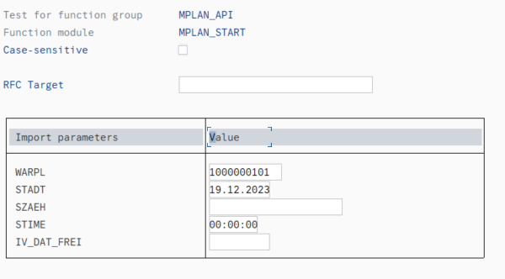
Fill in WARPL = created maintenance plan number
Fill in STADT = start date from uploaded data
After all proses have been processed, then return success message to user: “S – Maintenance Plan XXX successfully created and scheduled.”, else, show error message in message based on error message found or validated.

Output Parameter
Show all fields on input parameter as ALV report with additional 2 fields below:
Column Name | Logic
Message Type | Either Success or Error
Message | Description of message

Authorization Control

Security Requirements
Authorization Object | Level of Security | Composite Role

Appendix

Version 1.0 Deployment

Document Approval
Version | Date | Name | Organization/Title | Comments

Pre-Deployment Checklist

User Acceptance Test (UAT)
Version | Test Date | Name | Organization/Title | Comments

Post-Deployment Checklist

Approval
Version | Date | Name | Organization/Title | Comments

